**MoneyLion Test application Project**

**Software Architecture Document**

**Version 1.0**

**Revision History**

|  |  |  |  |
| --- | --- | --- | --- |
| **Date** | **Version** | **Description** | **Author** |
| 13-02-2021 | 1.0 | Software Architecture Document | Mohammedarief |
|  |  |  |  |
|  |  |  |  |
|  |  |  |  |

**Software Architecture Document**

**1. Introduction **

#### **1.1 Purpose**

This document provides an architectural overview of the system, using a number of different architectural views to depict different aspects of the system. It is intended to capture and convey the significant architectural decisions which have been made on the system.

#### **1.2 Scope**

This Software Architecture Document provides an architectural overview of the simple web application form with authentication which includes user details such as SSN,DOB,Name and Email address. The C-Registration System is being developed using asp.net,IIS web server, MSSQL and azure for hosting.

**2. Architectural Representation **

This document presents the architecture as a series of views; use case view, There is no separate implementation view described in this document.

**4. Use-Case View **

A description of the use-case view of the Moneytestapplication. It also describes the set of scenarios and/or use cases that have a substantial architectural coverage (that exercise many architectural elements) or that stress or illustrate a specific, delicate point of the architecture.

* The Moneytestapplication use cases are:
* Login
* Statusmessage
* Resetpassword confirmation
* Reset password
* Register confirmation
* Register
* Logout
* Login
* Lockout
* Forgotpasswordconfirmation
* Forgotpassword
* Confirmemailchange
* Confirmemail
* Accessdenied
* Changepassword
* Email
* Index
* Manage
* Setpassword

These use cases are initiated by the user.

**4.1 Architectural Design **

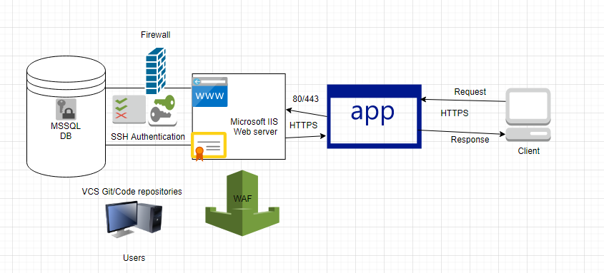

**Webserver - IIS 10**

**Asp.net 3.1.11**

**MSSQL- 8.0.15**

**Key Security Implementations:**

Created a contact form application using Asp.net MVC framework. Implemented access control, i.e. authentication for the application, requiring a user to authenticate first before the user is authorised to use the application.After successful authentication, the application presents a form interface to update and edit a user’s details, comprising of SSN,Name,DOB and email address.

For authentication included below security controls

1. Account lockout for burteforce attack
2. Strong password policy of using 8-14 characters includes special characters,numbers and alphabets.
3. Cookie protected using secure flag and http only flag.
4. Forgotpassword and recovery not built due to limited features but it can be configured securely by enabling flag for recovering passwords through password recovery.

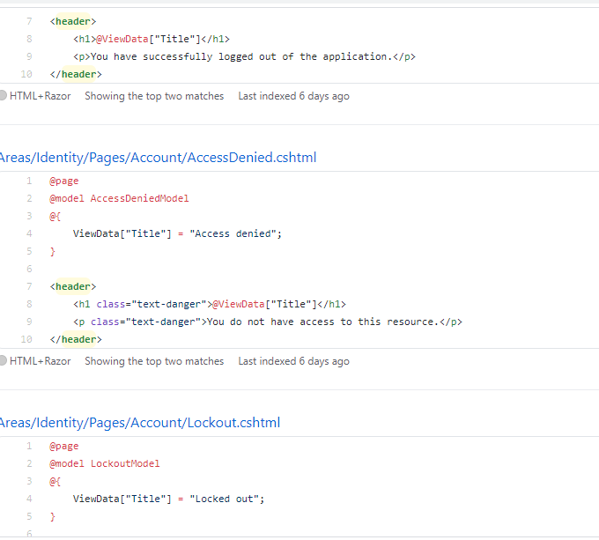

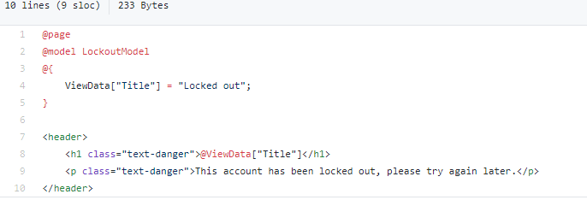

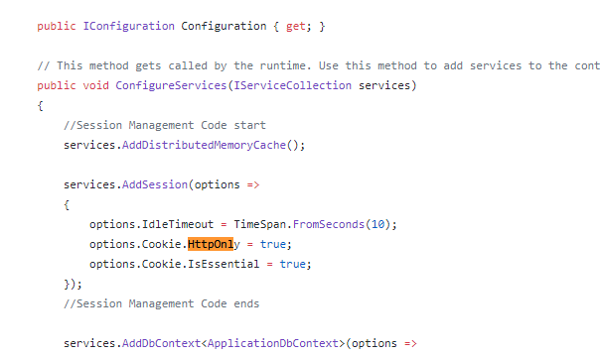

Data Validation:

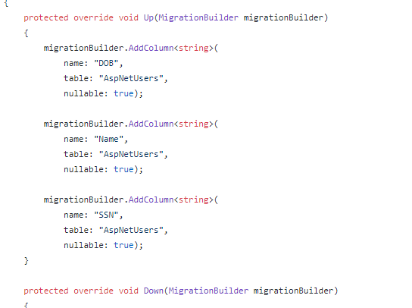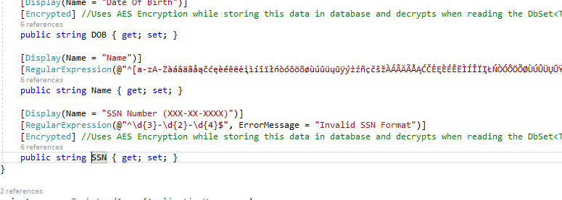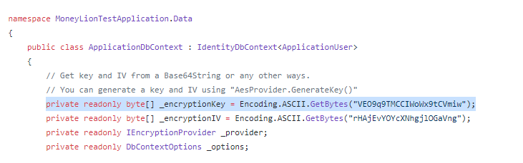

SSN,Email address,DOB,username and password are securely stored in the database using Microsoft.EntityFrameworkCore.DataEncryption.

**Header Security:**

XSS Protection mode,Xframe options and HSTS implemented for secure configurations.

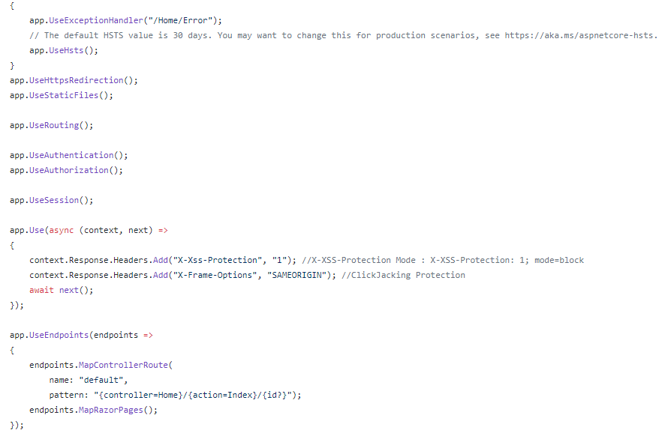

I tried implementing a CSP header but it's somehow blocking the external static pages.But I can work on the improvisation part on CSP implementation.

<httpProtocol>

<customHeaders>

<add name="Content-Security-Policy" value="default-src 'self'" />

</customHeaders>

</httpProtocol>

**External Libraries:**

I have used Bootstrap 4.3.1,Jquery 3.5.1 and [EntityFrameworkCore.DataEncryption 2.0.0](https://github.com/Eastrall/EntityFrameworkCore.DataEncryption).

All external libraries are reviewed and verified in terms of checking CVE and vulnerable functions.

*Note:Code manually reviewed,Dynamic testing performed on the application checking OWASP vulnerabilites and Threat modelling created separately.*